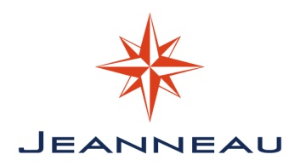
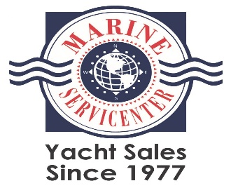

21st Annual Jeanneau Rendezvous

June 23-25, 2023

Itinerary

Schedule of Events

Friday, June 23, 2023
3:00 pm – 6:00 pm: Moorage check-in w/ Cap Sante marina office – please pay your moorage directly to Cap Sante Marina. Rendezvous registration with Marine Servicenter will be in the tented party floats. After you register with the Marina come see us and get your Skipper Bag!

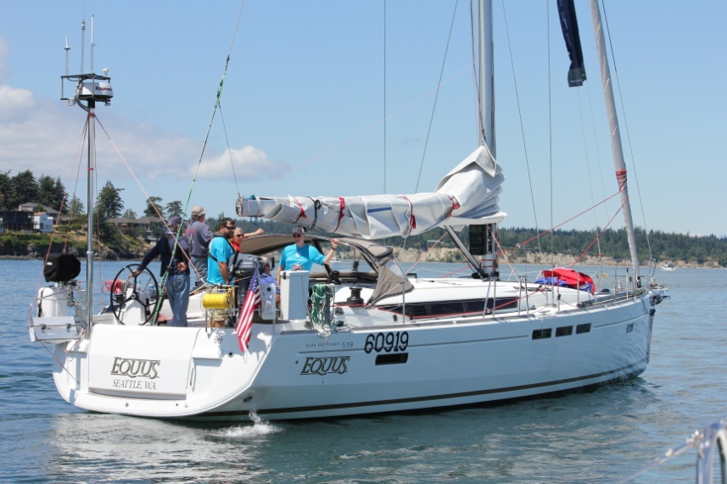
6:00 pm – 8:30 pm: Welcome Dock Party with Gere-a-Deli catered heavy appetizers. Beer, wine and soft drinks supplied by Marine Servicenter. Note – Jeanneau Owner nametags required to be served at this event. Location = Tented party floats, Cap Sante Marina. Please feel free to welcome fellow Jeanneau owners on board your boat, as this is a great time for socializing, open boat showings, and exchanging ideas.

Saturday, June 24, 2023
8:00 am – 10:00 am: Breakfast - on your own. Explore Anacortes Old Town and the Farmers Market at “The Depot,” an easy 2 block walk from the Marina

9:00 am – 5:00 pm: ALL-DAY EVENT – Jeanneau Owner Appreciation Day! Visit the West Marine Anacortes store at 918 Commercial Ave on this day ONLY for Discounted Pricing on any in store item. Rendezvous Name Badge must be presented at check out.

10:00 am – 12:00 pm: Seminars at “The Depot”, an easy 1 block walk north from the marina to Include:
- Whale Wise: Volunteers from the Whale Museum/ Soundwatch Program will outline the regulations and tips for Orca and other Whale Watching from your boat.
- Yanmar Engines: The Future of Yanmar Power – Electric and Hydrogen followed by Q&A session on your Diesel Engine and what is coming in the Future – Joe Mecurio Yanmar
or
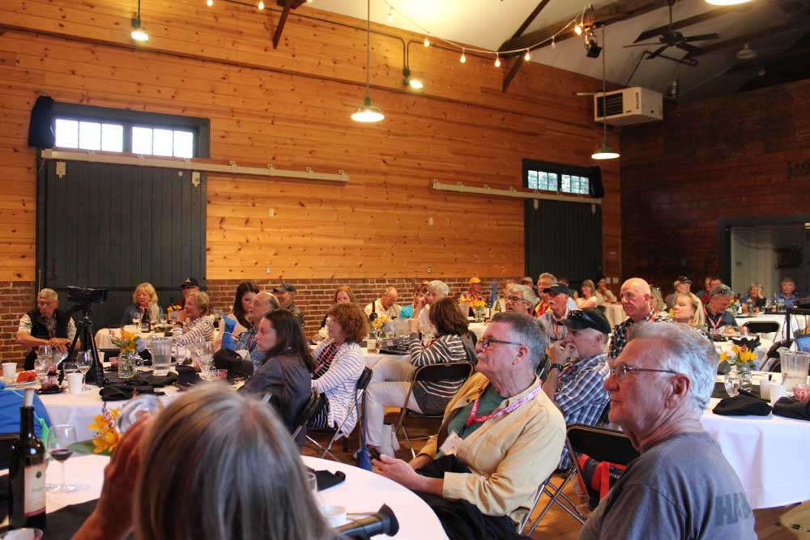
10:00 – 12:00 pm: Attend the famous Anacortes Farmers Market at “The Depot” (open 9 am – 2 pm), Just outside and to the north of the Seminar Room – 1 block north of Cap Sante Marina.
or
Explore Anacortes Old Town via free bicycle at the marina office or easy walking. Or hike to the top of Cap Sante – trail near P-Q Docks at the gazebo.

12:00 pm: Lunch - on your own.

1:00 pm – 4:00 pm: 21st Annual Jeanneau Parade of Yachts & Summer Sailstice sail-off!
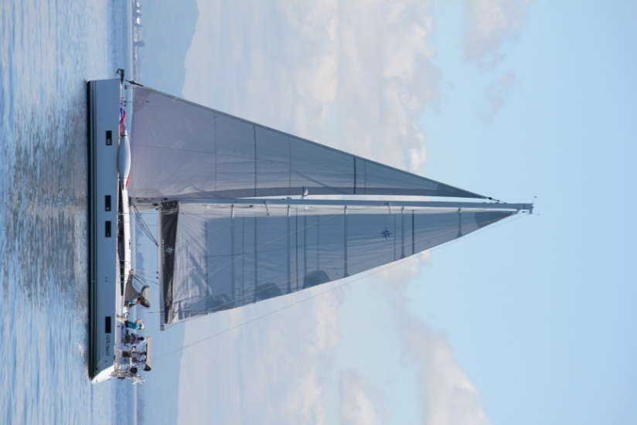
Get out and sail on the official holiday for sailors - “Summer Sailstice”. All participants have a chance to win coveted “parade awards” given out at the big dinner.
PNW Jeanneau Rendezvous | Summer Sailstice
* To be eligible for great Summer Sailstice prizes be sure to register your boat by creating an account

4:00 pm - 6:00 pm: Social Dock Walking & “Parade” Tall Stories
Welcome Parade Participants back to the dock, socialize on the dock and welcome fellow Jeanneau owners on board your boat. This is a great time for socializing, open boat showings, and idea exchange.

6:00 pm – 7:00 pm: Social Hour - on the outdoor garden terrace of “The Depot”, an easy 1 block walk from the marina. Beer & wine provided by Marine Servicenter during Social Hour only, Appetizers by Gere -a – Deli Note – Jeanneau Owner nametags are required to be served at this event. Enjoy a refreshing drink, catered passed apps, and socialize with fellow Jeanneau owners prior to the BIG JEANNEAU OWNERS CATERED DINNER!

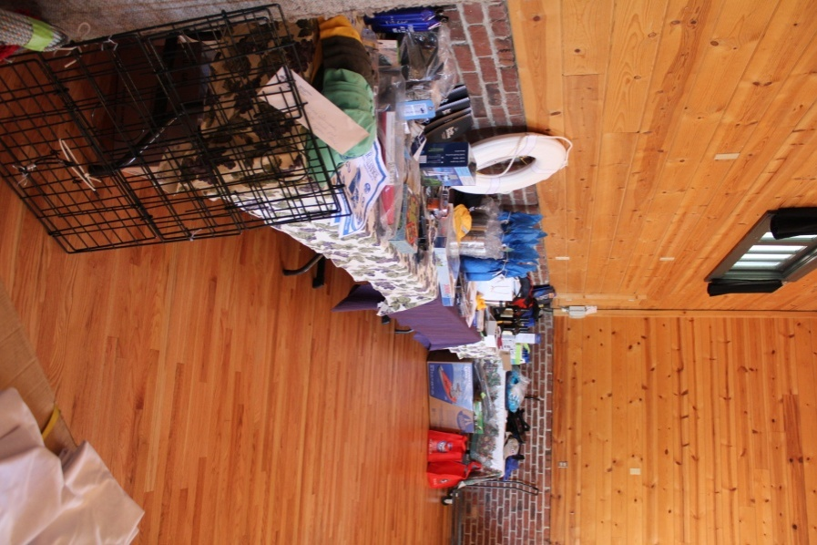
7:00 pm: The infamous PNW Jeanneau Owners Rendezvous Dinner at “The Depot” – an easy 1 block walk from the marina. Note – Jeanneau Owner nametags are required to be served at this event. NOTE – The Dinner is a BYOB EVENT, water only will be on tables - Bring your favorite bottle to your table and the bartender provided by the catering staff will open and pour for you. We have a liquor permit, bring anything you would like! Glasses and openers provided by catering staff.

Dinner Catered by Anacortes favorite, Gere-a-Deli to include:
- Arugula salad with balsamic
- Parmesan Cheese Rolls with Butter
- Wild Alaskan Sockeye Salmon
- Slow Roasted Prime Rib with Horseradish
- Champagne Chicken with Fresh Herbs
- Vegetarian Dish UPON REQUEST – Please let a Marine Servicenter Staff Member know before dinner, limited availability
- Roasted Summer Vegetables with Green Beans & Carrots
- Baby Red Mashers Potatoes
- Dessert - Lemon Chiffon Cake & Chocolate Tuxedo Cake
*Water & glasses provided at the event. BYOB EVENT: Bartender will open and pour wine and liquor. We have a banquet / liquor permit, thus there are no corkage fees for owners who BYOB!

8:30 pm: 21st Annual Pacific Northwest Jeanneau Rendezvous door prize extravaganza!
Fabulous prizes from some of the best marine vendors on the planet! Every Boat Wins! This annual prize give-away is always a hit!!!

9:30 pm: On your own – nightcap cocktails at an Old-Town pub
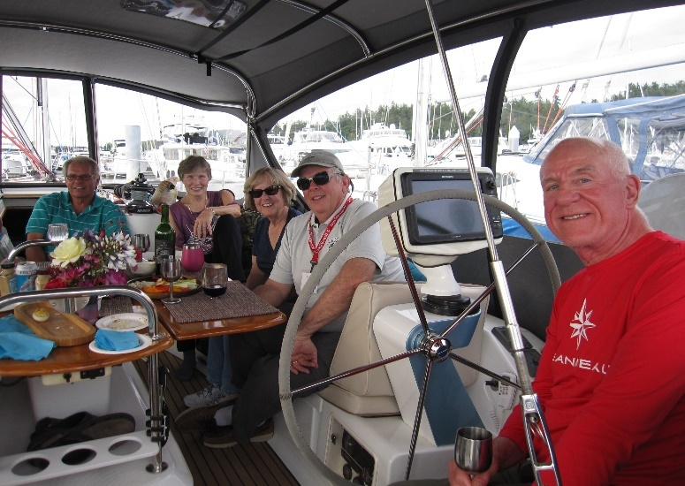

Sunday, June 25, 2023
8:30 am: Coffee, juice, fruit & rolls on the dock
Tented party floats, Cap Sante Marina
Bon Voyage Jeanneau Rendezvous Fleet. Location = Cap Sante Marina C-Dock

12:00 pm: Latest check out and leave Marina time
Race Week moves into the Marina on Sunday – All Boats must vacate slips by noon at the latest. Please remember to pay your guest moorage fees directly to the Marina prior to departure.

THANK YOU for attending the 21st Annual PNW Jeanneau Rendezvous!

Save the Date! 22nd Annual PNW Jeanneau Owners Rendezvous – Cap Sante Marina – Anacortes, WA. June 21-23, 2024

Premier Donators:

Anacortes Marine Documentation LLC

CSR Marine

LFS

Shore Premier Finance

Yachtworld.com

Yanmar

Sponsored & Organized By:
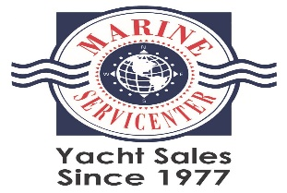 | 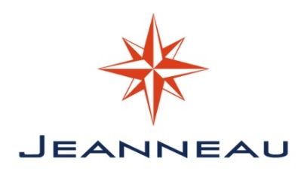
Marine Servicenter  Seattle • Bellingham • San Diego  www.marinesc.com info@marinesc.com  206-323-2405 | Jeanneau America  Ft Lauderdale, FL  www.jeanneau.com

